TO: Healthcare Providers in Catawba County
FROM: Catawba County Public Health Director Jennifer McCracken, RN, MPA
DATE: 01.07.2026
CONFIRMED MEASLES CASES IN POLK AND BUNCOMBE COUNTIES
HEALTH CARE PROVIDERS SHOULD STAY ALERT FOR MEASLES
Measles cases have been confirmed in Polk and Buncombe counties in North Carolina. These cases are from the same outbreak currently happening in Spartanburg County, South Carolina. Providers should remain vigilant in their screening of patients for measles symptoms and immediately notify suspected or confirmed cases to the Catawba County Health Department. To prepare for any potential measles cases, providers should have a preparedness plan in place to prevent additional exposure, including patient isolation and offering triaging and testing outside of the facility. For guidance on testing, i
Due to the recent cases, healthcare providers should be on alert for patients who have:
- Febrile rash illness and symptoms consistent with measles (e.g., cough, coryza, or conjunctivitis);
- Not been vaccinated for measles, have not completed their MMR vaccine series, or have an unknown immunity status;
- Recently traveled to the areas of Spartanburg County, South Carolina, Polk County, North Carolina and/or Buncombe County, North Carolina;
- Recently traveled abroad, especially to countries with ongoing measles outbreaks.
Prompt recognition, reporting, and investigation of measles are important because the spread of the disease can be limited with early case identification and vaccination of susceptible contacts.
Health care providers are required by North Carolina law to report cases of measles within 24 hours to the local health department. Providers should report both suspected/probable and laboratory-confirmed cases.
This is an evolving situation, and additional public health recommendations may be forthcoming if cases or outbreaks are identified in Catawba County.

Where to report
- Catawba County Public Health’s Communicable Disease Team: Call (828) 695-5800 (available 8 AM to 5 PM) or fax (828) 695-5103
- North Carolina’s Communicable Disease Branch (available 24/7): Call (919) 733-3419
North Carolina’s Communicable Disease Reporting Form: https://www.dph.ncdhhs.gov/epidemiology/communicable-disease/confidential-communicable-disease-report-fillable/open
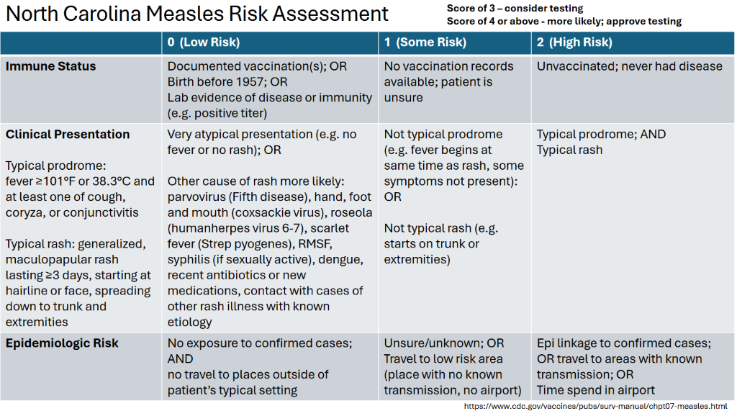
Isolate: Isolate your patient with suspected measles immediately, ideally in a single-patient airborne infection isolation room (AIIR), or in a private room with a closed door until an AIIR is available. Patients with measles should call ahead of time so healthcare facilities can limit additional exposures, including offering measles triaging and testing outside the facility. Do not allow patients with suspected measles to remain in the waiting room or other common areas of the healthcare facility. Immediately implement airborne isolation precautions for any patient with suspected or confirmed measles. Rooms that had been occupied by a suspect or confirmed measles patient should not be used for at least four hours after the patient leaves.
Test: Contact Catawba County Public Health’s Communicable Disease team at (828) 695-5800 or the state Communicable Disease Branch (919) 733-3419; available 24/7) immediately if measles is suspected to discuss laboratory testing and control measures). You will be provided with guidance on testing, isolating, and managing patients with suspected measles and people exposed to measles
Manage: In coordination with Public Health’s Communicable Disease Team, provide appropriate measles post-exposure prophylaxis to close contacts without evidence of immunity, either MMR or immunoglobulin. The choice of PEP is based on elapsed time from exposure or medical contraindications to vaccination.
Avoid Additional Exposures: Healthcare providers should be adequately protected against measles and should adhere to standard and airborne precautions when evaluating suspect cases, regardless of vaccination status.
Only health care personnel with documented immunity to measles (written documentation of two doses of measles containing vaccine, or laboratory evidence of immunity) should attend to patients with suspected or confirmed measles. Healthcare personnel without evidence of immunity who are exposed to measles should be offered the first dose of MMR vaccine and excluded from work from day 5 after the first exposure to day 21 following their last exposure.
Notify EMS and the receiving facility prior to transporting or referring patients with suspected or confirmed measles to avoid additional exposures.
Keep records of anyone who may have been exposed (e.g. other patients in the waiting room) and if possible, prevent exposures by making alternate testing arrangements (e.g. testing outside, using an alternate entrance, bringing the patient in as the last patient of the day).
Vaccinate: Parents consider their child’s healthcare professionals to be their most trusted source of information when it comes to vaccines; you have a critical role in helping parents choose vaccines for their child. Vaccination with MMR vaccine is the best way to protect against measles.
For questions about vaccinations or for patients who are uninsured or underinsured (medical plans do not cover vaccinations), please contact the Public Health Immunizations Clinic at (828) 695-5881.

